Coronavirus disease 2019 (COVID-19)
Situation Report – 93

Data as received by WHO from national authorities by 10:00 CEST, 22 April 2020

HIGHLIGHTS

- WHO is deeply saddened at the death of a member of personnel during a security incident in Rakhine district of Myanmar, who was transporting COVID- 19 surveillance samples in support of the Ministry of Health and Sports. WHO condemns targeting of health workers involved in the COVID-19 response. More information is available here.
- As of 22 April, Japan changed the method of reporting deaths, which now includes both the number of (i) deceased cases with complete data matching and verification; and (ii) deceased cases whose data matching and verification are in progress. The notable increase in the number of deaths reported from Japan can be attributed to this change.
- A WHO mission to Belarus has recommended the introduction of community- wide steps to increase physical distancing. More information is available here.
- OpenWHO has launched a new online course on Standard precautions: Hand hygiene. The module has been prepared to help summarize the WHO guidelines on hand hygiene, associated tools and ideas for effective implementation. To date, there has been more than 1.5 million enrolments in the platform's courses to support the COVID-19 response.

- The WHO Information Network for Epidemics (EPI-WIN) was launched at the beginning of the COVID-19 outbreak, specifically for infodemic management. For updates and more information, see the ‘Subject in Focus’ below.

- WHO issued guidance on Safe Ramadan practices in the context of COVID-19, which is available in Arabic, English, French, Russian and Spanish. For details, see the ‘Subject in Focus’ below.
SITUATION IN NUMBERS
total (new cases in last 24 hours)

Globally
2 471 136 confirmed (73 920)
169 006 deaths (6058)

European Region
1 219 486 confirmed (32 302)
109 952 deaths (3618)

Region of the Americas
925 291 confirmed (32 172)
44 775 deaths (2089)

Eastern Mediterranean Region
139 349 confirmed (4879)
6326 deaths (141)

Western Pacific Region
136 271 confirmed (1765)
5793 deaths (108)

South-East Asia Region
33 912 confirmed (2242)
1427 deaths (86)

African Region
16 115 confirmed (560)
720 deaths (16)

WHO RISK ASSESSMENT
Global Level Very High

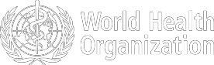

Figure 1. Countries, territories or areas with reported confirmed cases of COVID-19, 22 April 2020
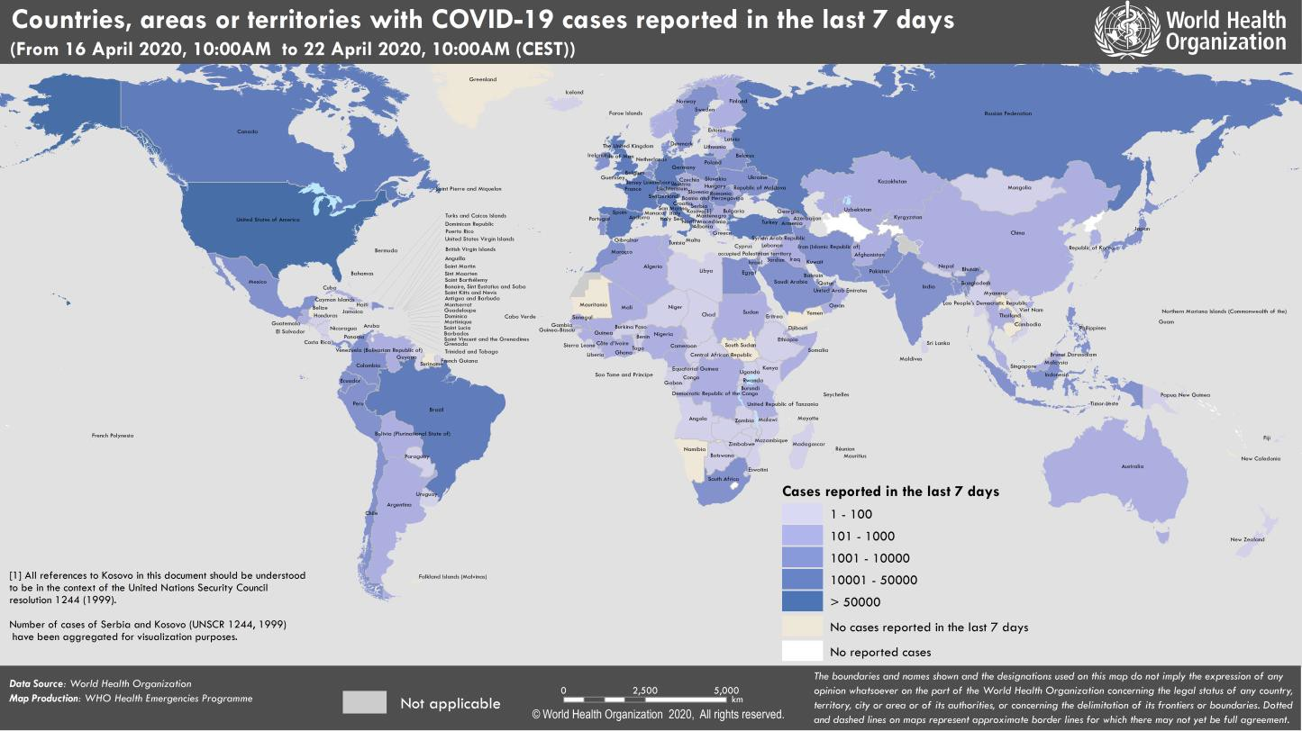

SUBJECT IN FOCUS: Infodemic management: the right information at the right time

The ongoing COVID-19 pandemic response requires rapid action from multiple sectors of society and government. Individuals need to adopt new behaviors; societies need to implement new public health measures; businesses need to develop new services to operate differently; faith leaders need to change practices to protect their communities; and the sports and entertainment sectors need to make difficult decisions to protect the public’s health. For this to happen, people need answers to their questions and advice designed for their needs and contexts. The WHO Information Network for Epidemics (EPI-WIN) was launched at the beginning of the COVID-19 outbreak, specifically to meet these information demands and those of future pandemics and emergencies.

Since January 2020, EPI-WIN has been engaging with some of the most vital sectors involved in the COVID-19 response through amplification webinars. The partnerships with the healthcare, business, faith, travel and tourism, food and agriculture and high-visibility events (sports and entertainment) sectors have helped EPI-WIN broaden the global reach of WHO’s life-saving risk communication messages significantly.

The Network has reached more than 160 health organizations or professional associations that bring together millions of frontline healthcare workers – the backbone of a country's defenses to save lives and limit the spread of disease. It also provided illustrated guidance to caretakers at home who play a vital role when health systems become overstretched.

In addition to engaging the health community, EPI-WIN has connected with the world’s employers and employees. With over 3 billion people in paid employment globally, the business sector serves as a major amplifier of information. EPI-WIN has directly connected with more than 400 businesses in food, agriculture, travel and tourism.

Approximately 84% of the world’s population identifies with a religious group and sadly many outbreaks of COVID-19 have been linked to faith gatherings. Faith-based organizations can and need to mobilize and inform millions of people through their churches, mosques, synagogues and temples. EPI-WIN has worked directly with more than 60 faith organizations to recommend critically important health behaviors for faith settings.

The Network also combats misinformation by providing transparent, evidence-based guidance as events unfold. The COVID-19 pandemic continues to evolve rapidly, making the need for updated, accurate and trusted information even more critical. EPI-WIN meets this information need, through behavior change and myth-busting messages. EPI- WIN’s science-based information has supported WHO’s website and social media channels. The EPI-WIN messaging is used on WHO’s COVID-19 website which has received 147 million page views since 22 January 2020. This information also fed the Google coronavirus page which received hundreds of millions of visitors every day, as well as a record of over 14.5 million users on WhatsApp and Viber.
EPI-WIN will continue to adapt and grow to meet the information needs of specific audiences as COVID-19 continues and as the world faces other future public health threats.

Stay abreast of new amplification activities at who.int/epi-win.
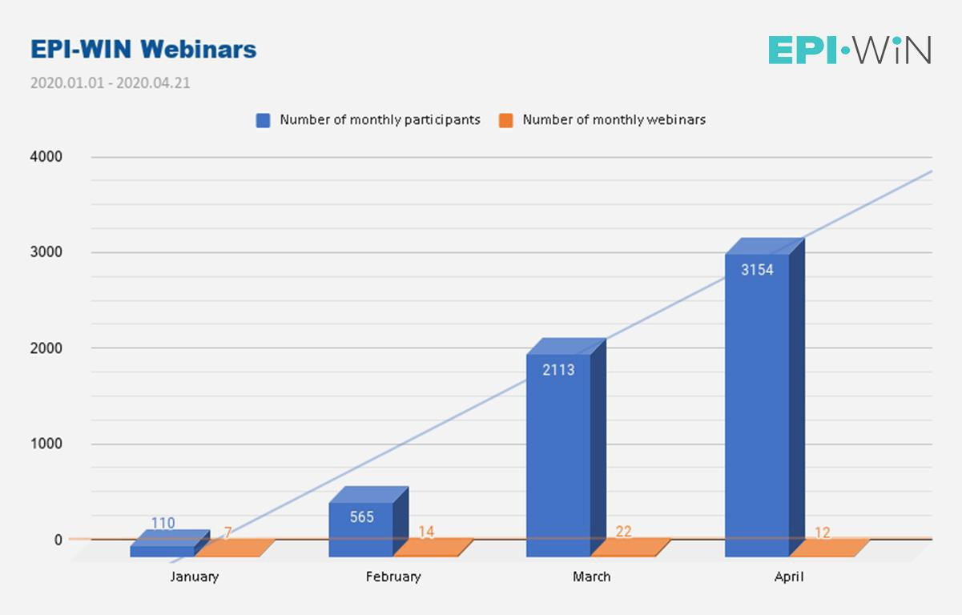
Figure 2. WHO Information Network for Epidemics (EPI-WIN) amplification webinars and participants since January 2020

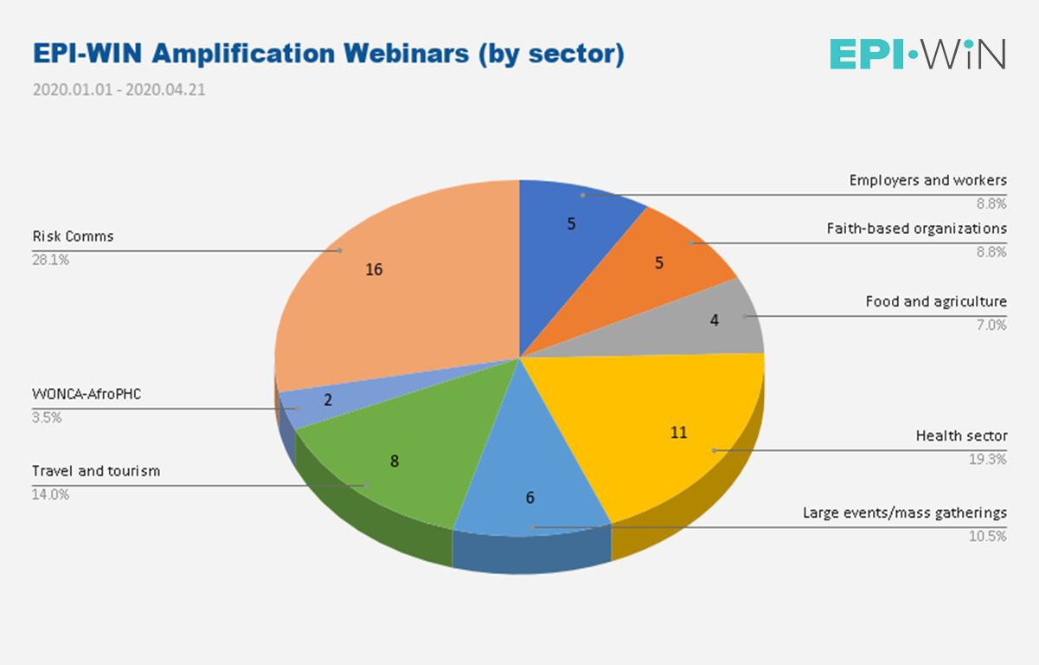
Figure 3. WHO Information Network for Epidemics (EPI-WIN) amplification webinars by sector
SUBJECT IN FOCUS: Safe Ramadan practices in the context of the COVID-19

Ramadan is the ninth month of the Islamic calendar and is observed by Muslims worldwide as a month of fasting from sunrise to sunset, prayer and reflection. It is marked by numerous religious and social gatherings, as families and friends unite to break their fast together, after sunset during iftar or before dawn during suhour.

As this year Ramadan is expected to start on 23 April and end on 23 May, thus falling during the ongoing pandemic of COVID-19, WHO has issued dedicated guidance on Safe Ramadan practices in the context of COVID-19. The purpose is to provide advice on gatherings occurring during the month of Ramadan, or immediately preceding and following it. Guidance was released on 15 April and is available in Arabic, English, French, Russian and Spanish.
The document is addressed to national health authorities with the aim of facilitating their role in establishing policies for events. Early involvement of religious leaders in the decision-making process is also recommended, so that they may disseminate information to the faithful community. In general, a strong communication strategy should ensure that decisions taken are explained to all those concerned in a timely and consistent manner.

As a first step, WHO recommends that decisions to restrict, modify, postpone, cancel or proceed with holding a mass gathering during Ramadan should be based on a rigorous and standardized assessment of the risks associated with such events in terms of contributing to the spread of COVID-19. Detailed guidance on risk-assessment protocols is included in Practical considerations and recommendations for Religious Leaders and Faith -based Communities in the context of COVID-19, with a risk-assessment tool and decision tree. Cancelling in-person events and holding them virtually, using platforms such as television, radio, digital and social media is therefore an option to be considered, especially if risk of transmission is significant.

The decision-making process can be facilitated by some overarching considerations related to physical distancing: for example, a distance of at least one metre (three feet) between people should be strictly maintained at all times during the event. People who are feeling unwell or have any symptoms of COVID-19 – as they may transmit the infection, and older people and anyone with pre-existing medical conditions should be discouraged from attending, as they have higher likelihood of developing severe illness.

If it is decided that physical gatherings shall go ahead, WHO recommends that mitigation measures be applied to further decrease risk of COVID-19 transmission during the planned event. Mitigation measures include: improving the venue’s facilities and arrangements (e.g. holding the event outdoors rather than indoors, or ensuring adequate ventilation), encouraging healthy practices by attendees (e.g. handwashing or taking safety steps in mosques, such as using personal prayer rugs), and ensuring that premises and often-touched objects are thoroughly and regularly cleaned.

The document also provides recommendations tailored to many social activities typical of Ramadan, such as the practice of charity (sadaqat or zakah), or the traditional iftar banquets, suggesting ways to safely live in full the spirit of Ramadan as the COVID-19 pandemic continues. Additional considerations pertaining to fasting, physical activity, healthy diet and nutrition, and tobacco use, as well as to mental and psycho-social health and response to domestic violence are also proposed with the aim of clarifying misconceptions, and providing advice that may help make the most out of the holy month of Ramadan and its myriad of celebrations.
SURVEILLANCE

Table 1. Countries, territories or areas with reported laboratory-confirmed COVID-19 cases and deaths. Data as of 22 April 2020*
Reporting Country/ Territory/Area† | Total confirmed  ‡ cases |  | Total confirmed new cases | Total deaths | Total new deaths | Transmission classification§ | Days since last reported case
Western Pacific Region
China |  | 84287 | 37 | 4642 | 0 | Clusters of cases | 0
Japan |  | 11496 | 378 | 277 | 91 | Clusters of cases | 0
Republic of Korea |  | 10694 | 11 | 238 | 1 | Clusters of cases | 0
Singapore |  | 9125 | 1111 | 11 | 0 | Clusters of cases | 0
Australia |  | 6647 | 22 | 74 | 3 | Clusters of cases | 0
Philippines |  | 6599 | 140 | 437 | 9 | Clusters of cases | 0
Malaysia |  | 5482 | 58 | 92 | 3 | Clusters of cases | 0
New Zealand |  | 1113 | 6 | 14 | 1 | Clusters of cases | 0
Viet Nam |  | 268 | 0 | 0 | 0 | Clusters of cases | 5
Brunei Darussalam |  | 138 | 0 | 1 | 0 | Sporadic cases | 2
Cambodia |  | 122 | 0 | 0 | 0 | Sporadic cases | 10
Mongolia |  | 34 | 1 | 0 | 0 | Sporadic cases | 0
Lao People's Democratic Republic |  | 19 | 0 | 0 | 0 | Sporadic cases | 9
Fiji |  | 18 | 0 | 0 | 0 | Sporadic cases | 1
Papua New Guinea |  | 7 | 0 | 0 | 0 | Sporadic cases | 5
Territories**
Guam |  | 133 | 0 | 5 | 0 | Clusters of cases | 10
French Polynesia |  | 57 | 1 | 0 | 0 | Sporadic cases | 0
New Caledonia |  | 18 | 0 | 0 | 0 | Sporadic cases | 19
Northern Mariana Islands (Commonwealth of the) |  | 14 | 0 | 2 | 0 | Pending | 4
European Region
Spain |  | 204178 | 3968 | 21282 | 430 | Pending | 0
Italy |  | 183957 | 2729 | 24648 | 534 | Community transmission | 0
Germany |  | 145694 | 2237 | 4879 | 281 | Community transmission | 0
The United Kingdom |  | 129048 | 4301 | 17337 | 828 | Pending | 0
France |  | 116151 | 2638 | 20763 | 530 | Community transmission | 0
Turkey |  | 95591 | 4611 | 2259 | 119 | Community transmission | 0
Russian Federation |  | 57999 | 5236 | 513 | 57 | Clusters of cases | 0
Belgium |  | 40956 | 973 | 5998 | 170 | Community transmission | 0
Netherlands |  | 34134 | 729 | 3916 | 165 | Pending | 0
Switzerland |  | 27981 | 119 | 1186 | 45 | Community transmission | 0
Portugal |  | 21379 | 516 | 762 | 27 | Pending | 0

Ireland | 16040 | 388 | 730 | 43 | Pending | 0
Sweden | 15322 | 545 | 1765 | 185 | Pending | 0
Austria | 14833 | 50 | 463 | 1 | Pending | 0
Israel | 13942 | 59 | 184 | 3 | Pending | 0
Poland | 9856 | 263 | 401 | 21 | Pending | 0
Romania | 9242 | 306 | 483 | 32 | Community transmission | 0
Denmark | 7695 | 180 | 370 | 6 | Pending | 0
Norway | 7166 | 53 | 163 | 9 | Pending | 0
Czechia | 7041 | 127 | 201 | 5 | Community transmission | 0
Serbia | 6890 | 260 | 130 | 5 | Pending | 0
Belarus | 6723 | 459 | 55 | 4 | Clusters of cases | 0
Ukraine | 6592 | 467 | 174 | 13 | Community transmission | 0
Finland | 4014 | 146 | 141 | 43 | Pending | 0
Luxembourg | 3618 | 60 | 78 | 3 | Pending | 0
Republic of Moldova | 2641 | 93 | 73 | 3 | Pending | 0
Greece | 2401 | 156 | 121 | 5 | Pending | 0
Hungary | 2168 | 70 | 225 | 12 | Clusters of cases | 0
Kazakhstan | 1995 | 143 | 19 | 0 | Pending | 0
Croatia | 1908 | 27 | 48 | 1 | Pending | 0
Iceland | 1778 | 5 | 10 | 0 | Pending | 0
Uzbekistan | 1657 | 0 | 6 | 1 | Clusters of cases | 1
Estonia | 1552 | 17 | 43 | 3 | Pending | 0
Azerbaijan | 1480 | 44 | 20 | 1 | Clusters of cases | 0
Armenia | 1377 | 38 | 24 | 2 | Clusters of cases | 0
Lithuania | 1370 | 20 | 38 | 1 | Pending | 0
Bosnia and Herzegovina | 1340 | 40 | 50 | 1 | Community transmission | 0
Slovenia | 1340 | 5 | 77 | 3 | Pending | 0
North Macedonia | 1231 | 6 | 55 | 1 | Clusters of cases | 0
Slovakia | 1199 | 26 | 14 | 1 | Clusters of cases | 0
Bulgaria | 975 | 46 | 45 | 2 | Pending | 0
Cyprus | 784 | 12 | 17 | 0 | Clusters of cases | 0
Latvia | 748 | 9 | 9 | 4 | Pending | 0
Andorra | 723 | 5 | 37 | 1 | Community transmission | 0
Albania | 634 | 25 | 26 | 0 | Clusters of cases | 0
Kyrgyzstan | 612 | 22 | 7 | 0 | Pending | 0
San Marino | 476 | 14 | 40 | 1 | Community transmission | 0
Malta | 443 | 12 | 3 | 0 | Pending | 0
Georgia | 411 | 3 | 5 | 1 | Clusters of cases | 0
Montenegro | 313 | 1 | 5 | 0 | Clusters of cases | 0
Liechtenstein | 82 | 0 | 1 | 0 | Pending | 3
Monaco | 68 | 0 | 1 | 0 | Sporadic cases | 8
Holy See | 9 | 0 | 0 | 0 | Sporadic cases | 1
Territories**

Kosovo[1] | 604 | 32 | 18 | 6 | Community transmission | 0
Isle of Man | 307 | 10 | 10 | 6 | Pending | 0
Jersey | 250 | 1 | 14 | 2 | Pending | 0
Guernsey | 239 | 0 | 10 | 1 | Community transmission | 2
Faroe Islands | 185 | 0 | 0 | 0 | Pending | 2
Gibraltar | 133 | 0 | 0 | 0 | Clusters of cases | 4
Greenland | 11 | 0 | 0 | 0 | Pending | 16
South-East Asia Region
India | 19984 | 1383 | 640 | 50 | Clusters of cases | 0
Indonesia | 7135 | 375 | 616 | 26 | Community transmission | 0
Bangladesh | 3382 | 434 | 110 | 9 | Pending | 0
Thailand | 2826 | 15 | 49 | 1 | Pending | 0
Sri Lanka | 310 | 6 | 7 | 0 | Clusters of cases | 0
Myanmar | 121 | 2 | 5 | 0 | Clusters of cases | 0
Maldives | 83 | 16 | 0 | 0 | Clusters of cases | 0
Nepal | 42 | 11 | 0 | 0 | Sporadic cases | 0
Timor-Leste | 23 | 0 | 0 | 0 | Clusters of cases | 1
Bhutan | 6 | 0 | 0 | 0 | Sporadic cases | 1
Eastern Mediterranean Region
Iran (Islamic Republic of) | 84802 | 1297 | 5297 | 88 | Community transmission | 0
Saudi Arabia | 11631 | 1147 | 109 | 6 | Clusters of cases | 0
Pakistan | 9749 | 533 | 209 | 17 | Clusters of cases | 0
United Arab Emirates | 7755 | 490 | 46 | 3 | Pending | 0
Qatar | 6533 | 518 | 9 | 0 | Pending | 0
Egypt | 3490 | 157 | 264 | 14 | Clusters of cases | 0
Morocco | 3209 | 163 | 145 | 2 | Clusters of cases | 0
Kuwait | 2080 | 85 | 11 | 2 | Clusters of cases | 0
Bahrain | 1973 | 66 | 7 | 0 | Clusters of cases | 0
Oman | 1614 | 106 | 8 | 0 | Clusters of cases | 0
Iraq | 1602 | 28 | 83 | 1 | Clusters of cases | 0
Afghanistan | 1092 | 66 | 36 | 0 | Clusters of cases | 0
Djibouti | 945 | 99 | 2 | 0 | Clusters of cases | 0
Tunisia | 901 | 17 | 38 | 0 | Community transmission | 0
Lebanon | 682 | 5 | 22 | 1 | Clusters of cases | 0
Jordan | 428 | 3 | 7 | 0 | Clusters of cases | 0
Somalia | 286 | 49 | 14 | 6 | Sporadic cases | 0
Sudan | 140 | 33 | 13 | 1 | Sporadic cases | 0
Libya | 59 | 8 | 1 | 0 | Clusters of cases | 0
Syrian Arab Republic | 42 | 3 | 3 | 0 | Community transmission | 0
Yemen | 1 | 0 | 0 | 0 | Pending | 11
Territories**
occupied Palestinian territory | 335 | 6 | 2 | 0 | Clusters of cases | 0
Region of the Americas

United States of America | 776907 | 25634 | 37602 | 1718 | Community transmission | 0
Brazil | 40581 | 1927 | 2575 | 113 | Community transmission | 0
Canada | 37374 | 1991 | 1728 | 117 | Community transmission | 0
Peru | 16325 | 697 | 445 | 45 | Community transmission | 0
Chile | 10832 | 325 | 147 | 8 | Community transmission | 0
Ecuador | 10398 | 270 | 520 | 13 | Community transmission | 0
Mexico | 8772 | 511 | 712 | 26 | Community transmission | 0
Dominican Republic | 5044 | 80 | 245 | 10 | Community transmission | 0
Panama | 4658 | 191 | 136 | 10 | Community transmission | 0
Colombia | 3977 | 185 | 189 | 10 | Community transmission | 0
Argentina | 3073 | 113 | 145 | 9 | Community transmission | 0
Cuba | 1137 | 50 | 38 | 2 | Clusters of cases | 0
Costa Rica | 662 | 2 | 6 | 1 | Clusters of cases | 0
Bolivia (Plurinational State of) | 598 | 34 | 34 | 1 | Clusters of cases | 0
Uruguay | 535 | 7 | 10 | 0 | Clusters of cases | 0
Honduras | 494 | 17 | 46 | 0 | Clusters of cases | 0
Guatemala | 294 | 5 | 9 | 2 | Clusters of cases | 0
Venezuela (Bolivarian Republic of) | 285 | 29 | 10 | 1 | Clusters of cases | 0
El Salvador | 225 | 7 | 7 | 0 | Clusters of cases | 0
Jamaica | 223 | 27 | 6 | 1 | Clusters of cases | 0
Paraguay | 208 | 0 | 8 | 0 | Community transmission | 1
Trinidad and Tobago | 114 | 0 | 8 | 0 | Sporadic cases | 6
Barbados | 75 | 0 | 5 | 0 | Clusters of cases | 5
Guyana | 66 | 1 | 7 | 0 | Clusters of cases | 0
Bahamas | 64 | 4 | 9 | 0 | Clusters of cases | 0
Haiti | 57 | 10 | 3 | 0 | Clusters of cases | 0
Antigua and Barbuda | 23 | 0 | 3 | 0 | Clusters of cases | 8
Belize | 18 | 0 | 2 | 0 | Sporadic cases | 7
Dominica | 16 | 0 | 0 | 0 | Clusters of cases | 11
Saint Kitts and Nevis | 15 | 0 | 0 | 0 | Sporadic cases | 1
Saint Lucia | 15 | 0 | 0 | 0 | Sporadic cases | 10
Grenada | 14 | 1 | 0 | 0 | Clusters of cases | 0
Saint Vincent and the Grenadines | 12 | 0 | 0 | 0 | Sporadic cases | 11
Nicaragua | 10 | 1 | 2 | 0 | Pending | 0
Suriname | 10 | 0 | 1 | 0 | Sporadic cases | 18
Territories**
Puerto Rico | 1298 | 46 | 64 | 1 | Clusters of cases | 0

Martinique | 163 | 0 | 14 | 0 | Clusters of cases | 3
Guadeloupe | 148 | 0 | 12 | 1 | Clusters of cases | 2
Aruba | 97 | 0 | 2 | 0 | Clusters of cases | 2
French Guiana | 97 | 0 | 1 | 0 | Clusters of cases | 1
Bermuda | 86 | 0 | 5 | 0 | Clusters of cases | 2
Sint Maarten | 68 | 1 | 10 | 0 | Clusters of cases | 0
Cayman Islands | 66 | 5 | 1 | 0 | Clusters of cases | 0
United States Virgin Islands | 54 | 1 | 3 | 0 | Clusters of cases | 0
Saint Martin | 37 | 0 | 2 | 0 | Sporadic cases | 3
Curaçao | 14 | 0 | 1 | 0 | Sporadic cases | 13
Falkland Islands (Malvinas) | 11 | 0 | 0 | 0 | Clusters of cases | 7
Montserrat | 11 | 0 | 0 | 0 | Sporadic cases | 8
Turks and Caicos Islands | 11 | 0 | 1 | 0 | Sporadic cases | 5
Saint Barthélemy | 6 | 0 | 0 | 0 | Sporadic cases | 22
Bonaire, Sint Eustatius and Saba | 5 | 0 | 0 | 0 | Sporadic cases | 4
British Virgin Islands | 4 | 0 | 1 | 0 | Sporadic cases | 2
Anguilla | 3 | 0 | 0 | 0 | Sporadic cases | 18
Saint Pierre and Miquelon | 1 | 0 | 0 | 0 | Sporadic cases | 14
African Region
South Africa | 3465 | 165 | 58 | 0 | Community transmission | 0
Algeria | 2811 | 93 | 392 | 8 | Community transmission | 0
Cameroon | 1163 | 0 | 43 | 1 | Clusters of cases | 1
Ghana | 1042 | 0 | 9 | 0 | Clusters of cases | 2
Côte d’Ivoire | 916 | 37 | 13 | 3 | Clusters of cases | 0
Guinea | 688 | 66 | 6 | 1 | Community transmission | 0
Niger | 657 | 2 | 20 | 0 | Clusters of cases | 0
Burkina Faso | 581 | 5 | 38 | 2 | Community transmission | 0
Nigeria | 541 | 0 | 19 | 0 | Community transmission | 2
Senegal | 412 | 35 | 5 | 0 | Clusters of cases | 0
Democratic Republic of the Congo | 359 | 9 | 25 | 0 | Clusters of cases | 0
Mauritius | 328 | 0 | 9 | 0 | Community transmission | 2
Kenya | 296 | 15 | 14 | 0 | Clusters of cases | 0
Mali | 258 | 12 | 14 | 0 | Clusters of cases | 0
United Republic of Tanzania | 255 | 0 | 10 | 0 | Clusters of cases | 1
Congo | 165 | 5 | 6 | 0 | Clusters of cases | 0
Gabon | 156 | 36 | 1 | 0 | Clusters of cases | 0
Rwanda | 150 | 3 | 0 | 0 | Clusters of cases | 0
Madagascar | 121 | 0 | 0 | 0 | Clusters of cases | 2
Ethiopia | 114 | 3 | 3 | 0 | Clusters of cases | 0

Liberia | 101 | 2 | 8 | 0 | Clusters of cases | 0
Togo | 86 | 2 | 6 | 1 | Clusters of cases | 0
Equatorial Guinea | 79 | 0 | 0 | 0 | Clusters of cases | 3
Zambia | 70 | 5 | 3 | 0 | Sporadic cases | 0
Cabo Verde | 67 | 12 | 1 | 0 | Sporadic cases | 0
Uganda | 56 | 1 | 0 | 0 | Sporadic cases | 0
Benin | 54 | 0 | 1 | 0 | Sporadic cases | 1
Guinea-Bissau | 50 | 0 | 0 | 0 | Sporadic cases | 4
Sierra Leone | 50 | 7 | 0 | 0 | Clusters of cases | 0
Eritrea | 39 | 0 | 0 | 0 | Sporadic cases | 3
Mozambique | 39 | 4 | 0 | 0 | Sporadic cases | 0
Chad | 34 | 1 | 0 | 0 | Sporadic cases | 0
Zimbabwe | 28 | 3 | 3 | 0 | Sporadic cases | 0
Angola | 24 | 0 | 2 | 0 | Sporadic cases | 1
Eswatini | 24 | 0 | 1 | 0 | Sporadic cases | 1
Botswana | 20 | 0 | 1 | 0 | Sporadic cases | 2
Malawi | 18 | 1 | 2 | 0 | Sporadic cases | 0
Namibia | 16 | 0 | 0 | 0 | Sporadic cases | 16
Central African Republic | 14 | 2 | 0 | 0 | Sporadic cases | 0
Burundi | 11 | 5 | 1 | 0 | Sporadic cases | 0
Seychelles | 11 | 0 | 0 | 0 | Sporadic cases | 15
Gambia | 10 | 0 | 1 | 0 | Sporadic cases | 1
Mauritania | 7 | 0 | 1 | 0 | Sporadic cases | 11
São Tomé and Príncipe | 4 | 0 | 0 | 0 | Sporadic cases | 15
South Sudan | 4 | 0 | 0 | 0 | Sporadic cases | 10
Territories**
Réunion | 410 | 2 | 0 | 0 | Clusters of cases | 0
Mayotte | 311 | 27 | 4 | 0 | Clusters of cases | 0
Subtotal for all Regions | 2470424 | 73920 | 168993 | 6058
International conveyance (Diamond Princess) | 712 | 0 | 13 | 0 | Not Applicable†† | 37
Grand total | 2471136 | 73920 | 169006 | 6058
*Numbers include both domestic and repatriated cases
†The designations employed and the presentation of the material in this publication do not imply the expression of any opinion whatsoever on the part of WHO concerning the legal status of any country, territory, city or area or of its authorities, or concerning the delimitation of its frontiers or boundaries. Dotted and dashed lines on maps represent approximate border lines for which there may not yet be fu ll agreement.
‡Case classifications are based on WHO case definitions for COVID-19.
§Transmission classification is based on a process of country/territory/area self-reporting. Classifications are reviewed on a weekly basis and may be upgraded or downgraded as new information becomes available. Not all locations within a given country/territory/area are equally affected; countries/territories/areas experiencing multiple types of transmission are classified in the highest category reported. Within a given transmission category, different countries/territories/areas may have differing degrees of transmission as indicated by the d iffering numbers of cases, recency of cases, and other factors.
Terms:
- No cases: Countries/territories/areas with no confirmed cases (not shown in table)
- Sporadic cases: Countries/territories/areas with one or more cases, imported or locally detected
- Clusters of cases: Countries/territories/areas experiencing cases, clustered in time, geographic location and/or by common exposures
- Community transmission: Countries/area/territories experiencing larger outbreaks of local transmission defined through an assessment of factors including, but not limited to:
  - Large numbers of cases not linkable to transmission chains
  - Large numbers of cases from sentinel lab surveillance
  - Multiple unrelated clusters in several areas of the country/territory/area
** “Territories” include territories, areas, overseas dependencies and other jurisdictions of similar status
[1] All references to Kosovo should be understood to be in the context of the United Nations Security Council resolution 1244 (1999).
†† As the international conveyance (Diamond Princess) is no longer occupied, transmission classification cannot be applied.

Due to differences in reporting methods, retrospective data consolidation, and reporting delays, the number of new cases may not always reflect the exact difference between yesterday’s and today’s totals. WHO COVID-19 Situation Reports present official counts of confirmed COVID-19 cases, thus differences between WHO reports and other sources of COVID-19 data using different inclusion criteria and different data cutoff times are to be expected.

Figure 4. Epidemic curve of confirmed COVID-19, by date of report and WHO region through 22 April 2020

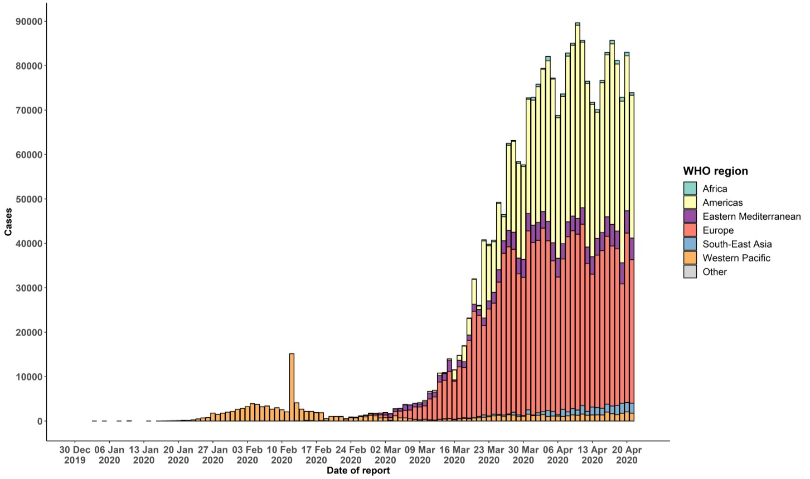
STRATEGIC OBJECTIVES

WHO’s strategic objectives for this response are to:

- Interrupt human-to-human transmission including reducing secondary infections among close contacts and health care workers, preventing transmission amplification events, and preventing further international spread*;
- Identify, isolate and care for patients early, including providing optimized care for infected patients;
- Identify and reduce transmission from the animal source;
- Address crucial unknowns regarding clinical severity, extent of transmission and infection, treatment options, and accelerate the development of diagnostics, therapeutics and vaccines;
- Communicate critical risk and event information to all communities and counter misinformation;
- Minimize social and economic impact through multisectoral partnerships.

*This can be achieved through a combination of public health measures, such as rapid identification, diagnosis and management of the cases, identification and follow up of the contacts, infection prevention and control in health care settings, implementation of health measures for travelers, awareness-raising in the population and risk communication.

PREPAREDNESS AND RESPONSE
- To view all technical guidance documents regarding COVID-19, please go to this webpage.
- WHO has developed interim guidance for laboratory diagnosis, advice on the use of masks during home care and in health care settings in the context of COVID-19 outbreak, clinical management, infection prevention and control in health care settings, home care for patients with suspected novel coronavirus, risk communication and community engagement and Global Surveillance for human infection with COVID-19.
- WHO is working closely with International Air Transport Association (IATA) and have jointly developed a guidance document to provide advice to cabin crew and airport workers, based on country queries. The guidance can be found on the IATA webpage.
- WHO has been in regular and direct contact with Member States where cases have been reported. WHO is also informing other countries about the situation and providing support as requested.
- WHO is working with its networks of researchers and other experts to coordinate global work on surveillance, epidemiology, mathematical modelling, diagnostics and virology, clinical care and treatment, infection prevention and control, and risk communication. WHO has issued interim guidance for countries, which are updated regularly.
- WHO has prepared a disease commodity package that includes an essential list of biomedical equipment, medicines and supplies necessary to care for patients with COVID-19.
- WHO has provided recommendations to reduce risk of transmission from animals to humans.
- WHO has published an updated recommendations for international traffic in relation to COVID-19 outbreak .
- WHO has activated the R&D blueprint to accelerate diagnostics, vaccines, and therapeutics.
- OpenWHO is an interactive, web-based, knowledge-transfer platform offering online courses to improve the response to health emergencies. COVID-19 courses can be found here and courses in additional national languages here. Specifically, WHO has developed online courses on the following topics:
  - Introduction to Go.Data – Field data collection, chains of transmission and contact follow-up. The Go.Data tool is available globally to WHO staff, member states and partners to support outbreak investigation, focusing on field data collection, contact tracing and visualisation of chains of transmission.
  - A general introduction to emerging respiratory viruses, including novel coronaviruses (available in Arabic, Chinese, English, French, Russian, Spanish, Hindi, Indian Sign Language, Persian, Portuguese, Serbian and Turkish);
  - Clinical care for Severe Acute Respiratory Infections (available in English, French, Russian, Indonesian and Vietnamese);
  - Health and safety briefing for respiratory diseases - ePROTECT (available in Chinese, English, French, Russian, Spanish, Indonesian and Portuguese);
  - Infection Prevention and Control for Novel Coronavirus (COVID-19) (available in Chinese, English, French,
Russian, Spanish, Indonesian, Italian, Japanese, Portuguese and Serbian); and
  - COVID-19 Operational Planning Guidelines and COVID-19 Partners Platform to support country preparedness and response (available in English and coming soon in additional languages).
- WHO is providing guidance on early investigations, which are critical in an outbreak of a new virus. The data collected from the protocols can be used to refine recommendations for surveillance and case definitions, to characterize the key epidemiological transmission features of COVID-19, help understand spread, severity, spectrum of disease, impact on the community and to inform operational models for implementation of countermeasures such as case isolation, contact tracing and isolation. Several protocols are available here. One such protocol is for the investigation of early COVID-19 cases and contacts (the “First Few X (FFX) Cases and contact investigation protocol for 2019-novel coronavirus (2019-nCoV) infection”). The protocol is designed to gain an early understanding of the key clinical, epidemiological and virological characteristics of the first cases of COVID-19 infection detected in any individual country, to inform the development and updating of public health guidance to manage cases and reduce the potential spread and impact of infection.

RECOMMENDATIONS AND ADVICE FOR THE PUBLIC

If you are not in an area where COVID-19 is spreading or have not travelled from an area where COVID-19 is spreading or have not been in contact with an infected patient, your risk of infection is low. It is understandable that you may feel anxious about the outbreak. Get the facts from reliable sources to help you accurately determine your risks so that you can take reasonable precautions (see Frequently Asked Questions). Seek guidance from WHO, your healthcare provider, your national public health authority or your employer for accurate information on COVID-19 and whether COVID-19 is circulating where you live. It is important to be informed of the situation and take appropriate measures to protect yourself and your family (see Protection measures for everyone).

If you are in an area where there are cases of COVID-19 you need to take the risk of infection seriously. Follow the advice of WHO and guidance issued by national and local health authorities. For most people, COVID-19 infection will cause mild illness however, it can make some people very ill and, in some people, it can be fatal. Older people, and those with pre-existing medical conditions (such as cardiovascular disease, chronic respiratory disease or diabetes) are at risk for severe disease (See Protection measures for persons who are in or have recently visited (past 14 days) areas where COVID-19 is spreading).

CASE DEFINITIONS

WHO periodically updates the Global Surveillance for human infection with coronavirus disease (COVID-19) document which includes case definitions.

For easy reference, case definitions are included below.

Suspect case
- A patient with acute respiratory illness (fever and at least one sign/symptom of respiratory disease, e.g., cough, shortness of breath), AND a history of travel to or residence in a location reporting community transmission of
COVID-19 disease during the 14 days prior to symptom onset.
OR
- A patient with any acute respiratory illness AND having been in contact with a confirmed or probable COVID-19 case (see definition of contact) in the last 14 days prior to symptom onset;
OR
- A patient with severe acute respiratory illness (fever and at least one sign/symptom of respiratory disease, e.g., cough, shortness of breath; AND requiring hospitalization) AND in the absence of an alternative diagnosis that fully explains the clinical presentation.

Probable case
- A suspect case for whom testing for the COVID-19 virus is inconclusive.
  - Inconclusive being the result of the test reported by the laboratory.
OR
- A suspect case for whom testing could not be performed for any reason.

Confirmed case
A person with laboratory confirmation of COVID-19 infection, irrespective of clinical signs and symptoms.
- Technical guidance for laboratory testing can be found here.

Definition of contact
A contact is a person who experienced any one of the following exposures during the 2 days before and the 14 days after the onset of symptoms of a probable or confirmed case:
- Face-to-face contact with a probable or confirmed case within 1 meter and for more than 15 minutes;
- Direct physical contact with a probable or confirmed case;
- Direct care for a patient with probable or confirmed COVID-19 disease without using proper personal protective equipment1; OR
- Other situations as indicated by local risk assessments.

Note: for confirmed asymptomatic cases, the period of contact is measured as the 2 days before through the 14 days
after the date on which the sample was taken which led to confirmation.

Definition of COVID-19 death
COVID-19 death is defined for surveillance purposes as a death resulting from a clinically compatible illness in a probable or confirmed COVID-19 case, unless there is a clear alternative cause of death that cannot be related to COVID disease (e.g. trauma). There should be no period of complete recovery between the illness and death.

Further guidance for certification and classification (coding) of COVID-19 as cause of death is available here.

1 World Health Organization. Infection prevention and control during health care when COVID-19 is suspected https://www.who.int/publications-detail/infection-prevention-and-control-during-health-care-when-novel-coronavirus-(ncov)- infection-is-suspected-20200125

